Provision a MS SQL Database Instance in Azure
SOP



Table of Contents

1. Provision a MS SQL Database Instance in Azure 3
1.1 Description 3
1.2 Architecture Diagram 3
1.3 Lab Steps 4
1.3.1 Automation 4
1.4 Troubleshooting 5
1.5 Supporting References 5

1. Provision a MS SQL Database Instance in Azure

1.1 Description
In this exercise you are going to provision a SQL Database using Azure portal. Microsoft Azure SQL Database is a managed cloud database provided as part of Microsoft Azure. Here you are going to deploy our SQL database on a SQL server which is to be created by us. The below architecture and lab steps can help you go through the exercise in a proper flow.

1.2 Architecture Diagram
The diagram below displays a visual representation of the application architecture:
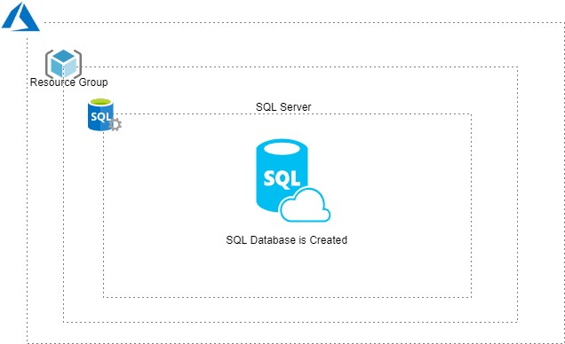

1.3 Lab Steps
Follow the steps outlined below to achieve the objective of this lab exercise:

- Open portal.azure.com.
- Use the login credentials to login.
- Search for SQL Databases in the search bar at the top of the page.
- Select the SQL database from the dropdown box.
- Select the Resource group and specify the database name as instructed.
- Click create new, under server.
- In the new server menu fill in the details such as Server name, Admin, Password and location must be East Us and then click select.
- Under configure+storage, select Configure database > Basic tab.
- Ensure that under storage tab, the Data max size is set to 2GB and then click apply.
- In Additional settings select the Data source as Sample and add the tags if required.
- Proceed to Review+Create option and wait for the validation and once it is done click on the create option.
Note: After few minutes your SQL Database is up and ready.
- Add the Geo-Replication by creating a server in other location for failover usage.
- Turn on the data encryption to keep the data safe.
- Mask data by going to Security, select Dynamic Data masking and add the masking rules as required. Now the SQL database is ready to use.

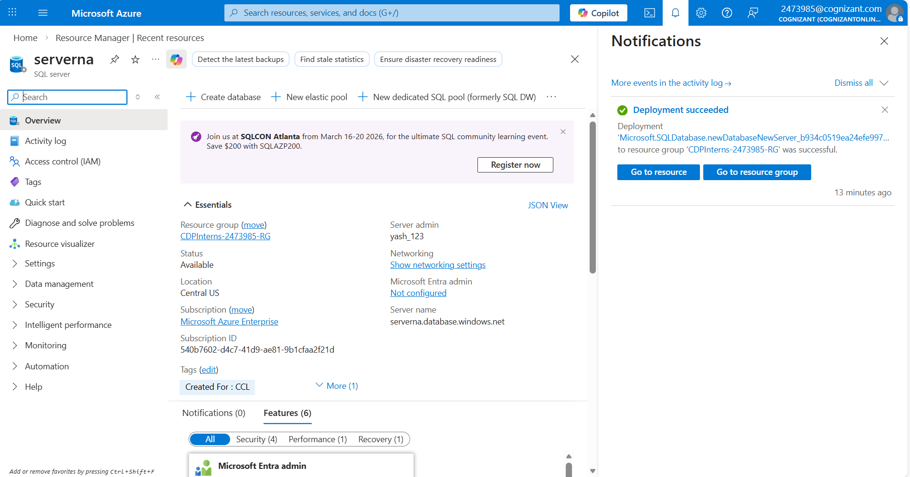

1.3.1 Automation
Follow the steps outlined below to make the lab exercise easy by simple automation.

- Open portal.azure.com.
- Go to the Azure cloud shell on top right on the portal.
- Once the connection is succeeded create a resource group by using the following command or use an existing resource group created for you (<Dept><empID>RG):
az group create --name <resource group name> --location <location name>
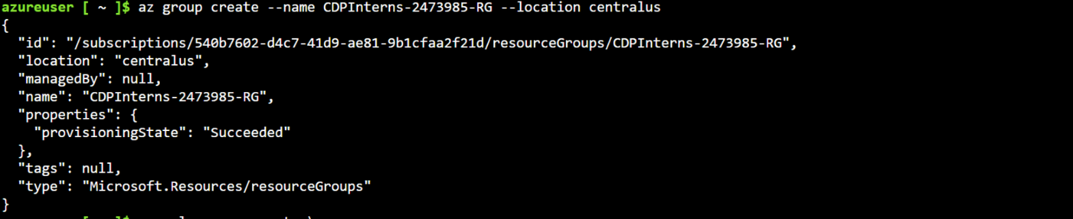 Create an SQL server under the same region with the following command:
az sql server create \ --name <name of the server> \
--resource-group <resource group name> \
--location <location name> \
--admin-user <admin name> \
--admin-password <password>

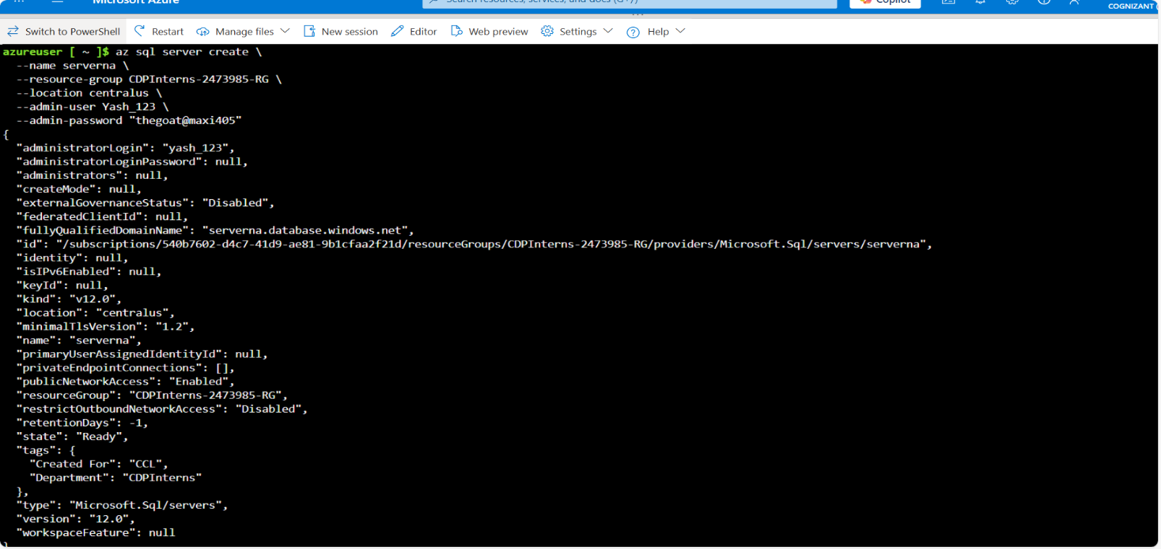
Note: The password must contain at least 1 lower case, 1 upper case, 1 numerical and 1 special character.
- Run the following command to proceed with the SQL Database creation, as your SQL server is created:
az sql db create –-resource-group <resource group name> --server <server name> --name <sql database name>

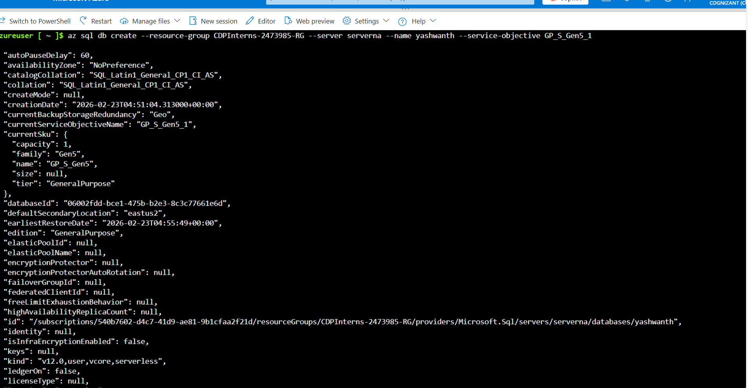

1.4 Troubleshooting
S. No | Problem | Solution
1 | Validation error during creation of SQL database. | - Server must be created under the region in which the resource group is present.  - Due to storage type it must be under your respective subscription.

1.5 Supporting References
Refer the below link for additional information:

1. https://docs.microsoft.com/en-us/azure/sql-database/sql-database-single-database-get-started?tabs=azureportal

